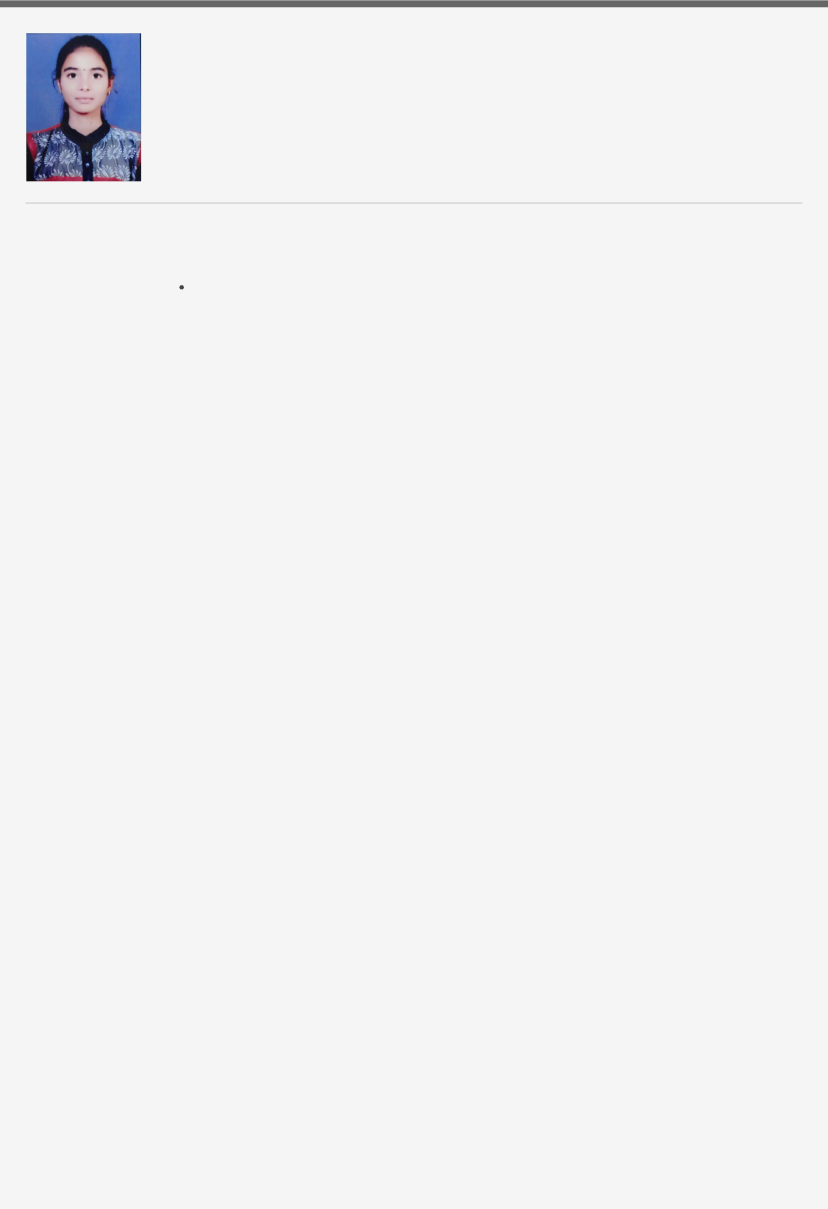AISHWARYA ASHOK BHIVATE

aishwaryabhivate1999@gmail.com 9579418708

66/67

A/p Hupari

Tal-Hatkanangle , Dist-Kolhapur

|  |  |  |
| --- | --- | --- |
| ***Objective*** | To work for an organization who provides me the opportunity to improve my Skills and |  |
|  | knowledge to grow along with the organizational |  |
|  |  |  |
| ***Skills*** | Team player |  |
|  | problem solver |  |
|  |  |  |
| ***Hobbies*** | Sketching,Painting,Reading,Dancing, Traveling |  |
|  |  |
|  |  |  |
| ***Language*** | Hindi,English,Marathi,Kannada |  |
|  |  |  |
| ***Education*** | ***Sharad Institute Of Technology College Of Engineering, Yadrav*** |  |
|  | B.Tech(Electronic and Telecommunications) |  |
|  | 07/2017 — **78.40%** |  |
|  |  |  |
|  | ***Parisanna Ingrole Junior college,Hupari*** |  |
|  | Higher Secondary Certification |  |
|  | 2017 — **57.38%** |  |
|  |  |  |
|  | ***Laxmidevi Girl's School,Hupari*** |  |
|  | Secondary School Certificate |  |
|  | 2015 — **72.00%** |  |
|  |  |  |
| ***Projects*** | **4Bit Shift Resistor** |  |
|  | 2017-18 |  |
|  |  |  |
|  | **Digital Switching** |  |
|  | 2018-19 |  |
|  |  |  |
|  | **Automatic Speed Control Of DC Motor Using PWM** |  |
|  | 2019-20 |  |
|  |  |  |
|  | **Automation in power loom** |  |
|  | 2020-21 |  |
|  |  |  |
|  | **Hand Safety** |  |
|  | 2020-21 |  |
|  |  |  |
|  | **Power Saving Of Looms** |  |
|  | 2020-21 |  |
|  |  |  |
| ***Industrial*** | **Aditya Birla Group** |  |
| ***Training*** | **Grasim Industries Jayashree Textiles Pvt.Ltd** |  |
|  | 6 months training in west Bengal(Kolkata) |  |
|  |  |  |
|  | **Autoflow Engineer’s & Controls Pvt.Ltd** |  |
|  | 15 days training in 5 star MIDC |  |
|  |  |  |
|  | **Power Engineers Pvt.Ltd** |  |
|  | 15 Days training in gokul shirgaon,Kolhapur |  |
|  |  |  |
| ***Workshops*** | Completed a one day workshop on "Robotech" at Yadrav |  |
|  |  |  |

Participated in the workshop for five days on "Embedded System Design And IOT" at Yadrav.



Completed a five days workshop on "Machine Learning" at IIT Bombay, Maharashtra

Participated in online course for five days on"Understanding Of Coastal Ocean Processes Using Remote Sensing and Numerical modelling" conducted by IIRS,ISRO,Dehradun.

***Certification***

***and***

***curricular***

***Activities***

Participated in "Paper Buzz"event in Walchand College Of Engineering, Sangli.

Participated in the event"Gyan-o-pedia" held at Kolhapur Institute Of Technology College Of Engineering, Kolhapur.

Participated in the event "Master Presenter"held at Sharad Institute Of Technology College Of Engineering, Yadrav.

|  |  |  |
| --- | --- | --- |
| ***Languages*** | C programming , Python |  |
|  |  |

***Computer***

***Skills-***

Computer knowledge including MS word, Excel, Power point.

Completed CCC.

|  |  |  |  |  |
| --- | --- | --- | --- | --- |
|  | ***Declaration*** | I here by declare that all the information provided by me in this application is factual | |  |
|  |  |  |
|  |  | and correct to the best of my knowledge and belief. | |  |
|  |  | Date: | |  |
|  |  | Place: | |  |
|  |  | Aishwarya Ashok Bhivate | |  |
|  |  |  |  |  |
|  |  |  |  |  |